**DESIGN AND IMPLEMENTATION OF WEB-BASED EMPLOYEES’ DAILY REPORT MANAGER FOR STETIS LIMITED**

**BY**

**ABDULKADIR AISHA USMAN**

**U14CS1082**

**A PROJECT PROPOSAL SUBMITTED TO THE DEPARTMENT OF COMPUTER SCIENCE, FACULTY OF PHYSICAL SCIENCES, AHMADU BELLO UNIVERSITY, ZARIA.**

# **DECLARATION**

I, Abdulkadir Aisha Usman, hereby declare that this project titled Design and Implementation of Employees’ Daily Report Manager for Stetis limited has been carried out by me under the supervision of Dr. O.N. Oyelade. It has not been presented for award of any degree in any institution. All sources of information are specifically acknowledged by means of reference.

…………………………… …………………….

Signature Date

# **CERTIFICATION**

This project entitled “DESIGN AND IMPLEMENTATION OF WEB-BASED EMPLOYEES’ DAILY REPORT MANAGER FOR STETIS LIMITED” by Abdulkadir Aisha Usman meets the requirements governing the award of the degree of Bachelor of Science in Computer science and is approved for its contribution to knowledge and literary presentation.

-------------------------------------------------- -------------------------

Dr. O.N. Oyelade Date

Supervisor

--------------------------------------------------- -------------------------

Prof. S.B. Junaidu Date

Head of Department

External Examiner

Name: Prof. S.E Adewumi -----------------------

Date

Signature: ----------------------------------------------

# **DEDICATION**

This project work is dedicated to my family and the family of Engr. Muhammad S. Adamu for their love and support.

# **ACKNOWLEDGEMENT**

I am most grateful to Almighty Allah for granting me this opportunity to be counted among the living. Special thanks to my incredible supervisor Dr. O.N. Oyelade for his encouragement, understanding and patient in the course of this project. His constructive criticisms and immense contribution, despite his tight schedules, led to the realization of this research work.

Immeasurable thanks also goes to Mal. Isiaka Ismaila of Stetis Limited for his constructive criticism and willingness to help in improving this project. May Almighty continued to protect, guide and bless him throughout his life endeavor.

My sincere gratitude goes the course mates and friends for their words of encouragement and supports. Most importantly, I want to appreciate Engr. Muhammed S. Adam for his effort, encouragement, support and prayers.

Lastly, I want to appreciate my parents and siblings who were also by side during the period of this study. I appreciate you all.

# **TABLE OF CONTENT**

**DECLARATION** i

**CERTIFICATION** ii

**DEDICATION** iii

**ACKNOWLEDGEMENT** iv

**TABLE OF CONTENT** v

**LIST OF FIGURES** viii

**LIST OF TABLES** ix

**ABSTRACT** x

**CHAPTER ONE** 1

**INTRODUCTION** 1

**1.1 Background of Study** 1

**1.2 Problem statement** 2

**1.3 Motivation** 2

**1.4 Aim and Objectives** 3

**1.5 Methodology** 3

**1.6 Organization of Project** 4

**1.7 Definition of Terms** 5

**CHAPTER TWO** 6

**LITERATURE REVIEW** 6

**2.1 Introduction** 6

**2.2 Human Resource Management** 6

**2.2.1 Employees and Work output** 7

**2.2.2 Workflow and Daily Report** 8

**2.3 Impact of Information and Communication Technologies in Workplace** 9

**2.3.2 Use of Automated Systems in Workplace** 10

**2.4 Challenges of management systems in Workplace and Daily Report** 11

**2.5 Related works** 12

**CHAPTER THREE** 14

**DESIGN OF EMPLOYEE DAILY REPORT MANAGER** 14

**3.1 Introduction** 14

**3.2 System Architecture** 14

**3.3 Dataflow flow diagram (DFD) of the system** 15

**3.4 Flow Chart** 16

**3.5 Database Design** 17

**3.5.1 Schema** 17

*3.5.2 Entity Relationship (ER) Diagrams* 18

*3.5.3 Tables* 19

**3.6 Tools** 25

*3.6.1* *HTML5 (HyperText Markup Language version 5)* 25

*3.6.2* *CSS3 (Cascading Style Sheet version 3)* 25

*3.6.3. JavaScript and Jquery* 26

*3.6.4 PHP7 (Hypertext pre-processor version 7)* 26

*3.6.4 XAMPP* 27

*3.6.5* *MySQL* 27

*3.6.6* *Sublime Text version 3* 27

**CHAPTER FOUR** 29

**IMPLEMNTATION OF EMPLOYEE DAILY REPORT MANAGER** 29

**4.1 Introduction** 29

**4.2 System Requirement** 29

**4.3 Application User Interface** 30

*4.3.1 The Login Page* 30

*4.3.2 The Report Page* 31

*4.3.3 Task page* 32

*4.3.4 Subordinate page* 34

*4.3.5 Users page* 34

**4.4 Application testing** 35

*4.4.1 Interface testing* 35

*4.4.2 Usability Testing* 36

*4.4.1 Acceptance Testing* 36

**4.5 Discussion** 37

**CHAPTER FIVE** 39

**SUMMARY, CONCLUSION AND RECOMMENDATION** 39

**5.1 Introduction** 39

**5.2 Summary** 39

**5.3 Conclusion** 39

**5.4 Recommendations** 39

**REFERENCE** 41

**APPENDIX** 42

# **LIST OF FIGURES**

Figure 3. 1: The architecture of the system 15

Figure 3. 2: The Data flow diagram (DFD) of employee daily report manager 15

Figure 3. 3: Flow chart diagram of the system 17

Figure 3. 4: The entity relationship diagram of the database schema 20

Figure 4. 1: The login page for the system 32

Figure 4. 2: The report page 33

Figure 4. 3: The add report page where a user can create new report. 33

Figure 4. 4: Submit a report 34

Figure 4. 5: Create new task page 34

Figure 4. 6: The view tasks page 35

Figure 4. 7: The remark page. 35

Figure 4. 8: The subordinate page 36

Figure 4. 9: The users’ tables 36

# **LIST OF TABLES**

Table 3. 1: Daily 21

Table 3. 2: Department 21

Table 3. 3: Designation 21

Table 3. 4: Permission 22

Table 3. 5: Report_summary 22

Table 3. 6: Role 22

Table 3. 7: Role_perm 23

Table 3. 8: Subordinate 23

Table 3. 9: Tasks 24

Table 3. 10: Task_participants 24

Table 3. 11: Users 25

Table 3. 12: User_role 25

Table 3. 13: Weekly 25

# **ABSTRACT**

Employees daily report is a document prepared by employees for submission to their supervisors. This project presents a work on a web-based Employees daily report manager for Steits limited. The system automates the manual system of reporting employees’ daily activities in the organization. The system is designed using the three tier-architecture, and the architecture design was implemented using the following web technologies: Hypertext Markup Language (HTML), Cascading Style Sheet (CSS) were used for the layering and presentation of the contents to be displayed by the browser, JavaScript and it dependent frameworks (Jquery and ajax) were used to achieve interactivity and dynamism between the different pages. PHP was used as the programming language to achieve client-to-server communication and MYSQL was used to implement the database design for proper record management. At the end of design and implementation, the application will manage the daily reports of employees in Stetis Limited.

# **CHAPTER ONE**

# **INTRODUCTION**

## **1.1 Background of Study**

The internet is the largest global set of computer communication network which renders a whole lot of different transactions from the business, engineering, medicine and to other services that involve our daily life. A daily report is typically a document prepared by employees to submit to their supervisors *(Skyler, 2018)*. Many companies require their employees to report their daily activities to their supervisors either daily, weekly or monthly depending on the company’s policies. All these reports are verified or acknowledged by the manager and graded based on the employee’s performance. The company may provide a template in a form of excel sheet or Microsoft file for their employees to fill-up to give information about their daily activities.

A standard employees’ report contains details on how they spent their work day, including achievements or challenges they encountered. If a particular project is underway, the daily report serves the purpose of updating the supervisor on the project status. There are numerous ways of creating and maintaining an employee’s daily report. This may be through the manual process of using a logbook that the manger can check from time to time. It can also be a single documentation per day which can be compiled in a physical folder and submitted to the manager manually or sent electronically via email *(status, 2017).*

The ideal reason for the daily documentation of the employees’ daily accomplishment by a company is to see the progress of each employee and their contribution towards the company’s goals. It also helps the employee to see his/her performance and contributions to the overall progress of a team work or project and also get to appreciate other team members’ contributions.

## **1.2 Problem statement**

It has been observed that there are many problems associated with the manual process of using the logbook to report daily activities by the employees in an office. These includes the problems of late review of the report by the supervisor due to the fact that the supervisor may be engaged in some other activities and may not have time for an immediate perusal of the submitted report. This could lead to delay in employee’s work if there is an urgent action pointed out by the employee that need an immediate attention of the supervisor. Other problems include loss of records due to natural disaster such as fire outbreak, floods and others.

This application is designed to provide solutions to the problems of the manual process of reporting daily activities and to give an employee an access control to his/her reports. It also provides a medium for supervisors to assign a task for to employees and also review tasks or reports submitted to them.

## **1.3 Motivation**

Seeing the way technology has impacted all aspects of human endeavor like business, engineering, medicine and other aspects of life, which made data processing and information exchange faster and more efficient is one of the driving force for the developing of this application.

The motive for designing this application is the desire to solve problems employees face daily in reporting their activities in the organization and so I took advantage the internet to build a web-based application that provide an easy and efficient way of managing employees daily reports while tackling the problems of the manual process of writing daily reports by the employee.

## **1.4 Aim and Objectives**

The aim of this project is to design and implement a web-based employees’ daily report manager that will keep track of their activities for the week.

The primary objectives of the projects are to:

1. Design a login system for the supervisors and the employees to access the portal.
2. Develop a function that allow the supervisor to assign a task to an employee.
3. Design an interface that will enable an employee to report their daily activity and state the challenges they encounter during the week and make suggestions to solve the problems.
4. To design function that sends an email notification when a report is submitted or viewed.
5. Design a database that will provide an immediate storage and retrieval of data and information from the database.

## **1.5 Methodology**

In other to achieve the objectives above, the following steps will be taken:

1. A literature review on the existing systems will be performed in other to ensure the originality of the work.
2. Hypertext Markup Language (HTML) and Cascading Style Sheet (CSS) will be used markup texts and style the interfaces and the login system respectively.
3. JavaScript will be used to add interactivity to the website.
4. Hypertext preprocessor (PHP) will be used as the server side scripting language to communicate with the database and form validation.
5. A database will be design for storing and retrieving employees’ reports using the MYSQL Database Management system (DBMS).
6. XAMP application will be used as the local server for the project.
7. Sublime text and intelliJ IDE will be used as the text editor.
   1. **Scope and Limitation**

This project provides number of features that simplifies the process of writing, editing, submitting and viewing of a report. The system provides the following functionalities:

1. An access control to users i.e. a user must login before the system will be access. Also it also has restrictions to what a regular user can do/view and what an admin or super admin can do/view with the system
2. The system can send a notification to an employee whenever his/her report has been viewed via his/her email.
3. The system provides a function which allow supervisors to assign a work to the employee.

However, the following are the limitations of the system:

1. The cannot generate a report template for the employees. This is because the system is design to manage the employees reports only.
2. The employee cannot schedule a work plan with the system.

## **1.6 Organization of Project**

This project is grouped into five different chapters. The basic idea behind each chapter is explained below.

Chapter One: gives an overview of the project, the aim and objectives of the project, the motivation of the project, the methodologies used in developing the project and the project outline.

Chapter Two: gives a literature review on the project i.e. an overview of existing system related to the projects.

Chapter three: this give the detailed explanation of design of the system.

Chapter four: give details of the implementation of the system and discussion of the results.

Chapter four: this is the last chapter of the project and it gives a summary of the whole project, with conclusion and recommendation.

## **1.7 Definition of Terms**

1. Employee: An individual who works part-time or full-time under a contract of employment, whether oral or written, express or implied, and has recognized rights and duties.
2. Report: A document containing information organized in a narrative, graphic, or tabular form, prepared on ad hoc, periodic, recurring, regular, or as required basis. Reports may refer to specific periods, events, occurrences, or subjects, and may be communicated or presented in oral or written form.
3. Web application/web app: a client–server computer program which the client (including the user interface and client-side logic) runs in a web browser.

# **CHAPTER TWO**

# **LITERATURE REVIEW**

## **2.1 Introduction**

As the number of users of the Internet increases every day, its use in different areas is also growing. This means that most works that are done manually can be automated into a web-based application. This enables efficiency, correctness, easy-flow of work and so on. This chapter presents a review of literature that are related to employee daily report management. Section 2.2 discussed human resource management, section 2.2.1 presented employees and work output, section 2.2.2 presented workflow and daily report, section 2.3 discussed the impact of Information and Communication Technology (ICT) in workplace, section 2.3.1 presented the Internet and web applications, Section 2.3.2 discussed about the use of automated systems in workplace, section 2.4 presented the challenges of managing systems in workplace and daily report and finally section 2.5 discussed about the related works

## **2.2 Human Resource Management**

Human Resource Management (HRM) is the term used to describe formal systems devised for the management of people within an organization. The responsibilities of human resource manager can be categorized into three major areas: staffing, employee compensation and benefits, and defining/designing work. The purpose of human resource management is to maximize the productivity of an organization by optimizing the effectiveness of its employees. This mandate is unlikely to change in any fundamental way, despite the ever-increasing pace of change in the business world. As Edward L. Gubman (1996) observed in the Journal of Business Strategy, “the basic mission of human resources will always be to acquire, develop, and retain talent; align the workforce with the business; and be an excellent contributor to the business.”

### **2.2.1 Employees and Work output**

An employee is a person who has agreed to be employed to work for some form of payment under a contract of service *(employee New Zealand, 2018).* The employee is hired by the employer after an application and interview process results in his or her selection as an employee. This selection occurs after the application is found by the employer to be the most qualified applicant to do the job.

A good employee is an asset to any organization as the key to the organization’s success is the effectiveness of the employees working in it. In such a scenario it is vital to pay importance to employee satisfaction. It is always necessary to address the fair needs of an employee and attend to his or her grievances to create job satisfaction, improve efficiency and a happy working environment. A happy employee is a productive employee and productivity is what contributes to the growth of any organization *(Output time, 2018).*

No matter what kind of products or services a business offers, it is important to measure employee productivity, and to measure it as accurately as possible.

Ensuring productivity in the workplace can be challenging. A 2013 Gallup survey revealed that 70 percent of U.S. workers are disengaged from their workday. Distracted by smartphones, social media, personal emails and the demands of their personal lives, most employees find it hard to focus consistently and produce the best work they can.

This lack of interest and involvement often leads to low or mediocre productivity. Accurately measuring employees' productivity is one clear way to gain insight into how skilled, engaged and productive employees are *(Universalclass,2018).*

Taking accurate productivity measurements can mean more than simply counting the number of products made or sold, or services performed. For instance, a toy factory worker might produce 100 toys each day. But if most of those toys are defective and unsellable, that employee's productivity level is not very high, and both work time and materials are being wasted.

When a company measures employees' productivity and discuss what they discover with the employees, they're letting them know that they expect the employee to care about their work, perform it as well as they can, and work toward achieving individual goals that are aligned with company goals.

In addition to revealing how individual employees are performing, these measurements can also reveal where the work flow gets slowed down or stopped due to equipment breakdowns, inefficient processes, poor job training, or lack of communication, among other problems.

A research carried out by Abugre (2012) revealed that regular interactions between managers and employees have a direct positive effect on employee work output. For an organization to make any significant impact on performance, both managers and their subordinates must have a very good climate of social interactions. The involvement of lower level employees in organizational activities and decision making is of crucial importance to organizational performance.

## **2.2.2 Workflow and Daily Report**

An employee’s daily report is a documentation of his or her performance, activities, accomplishments and achievements in a given work day *(status.net, 2018).*

By maintaining a daily report, an employee will have a bigger picture of how and where he spends most of his time. It will help them plan their day and days ahead and make sure that they do not forget the important things he needs to do for that day. They will also know how to schedule their tasks depending on the time of the day when they are more productive and then work on the lighter task during the time of the day when they are less productive.

On the employer side, daily report provides an effective way of monitoring employees daily accomplishments and performance and ensuring that the team members are still engaged with their jobs.

## **2.3 Impact of Information and Communication Technologies in Workplace**

The development of information and communication technologies (ICTs) in work place has changed the way we work in many different ways such as instant transfer of information and making organizations more efficient by cutting down the time it takes to transfer information. ICT has changed the employment structure and working practices. The use of computer and Internet in workplace has eliminated space and time boundaries. Employees can work from anywhere at any time. It Reduces on human errors which can be caused by much work or stress. Business technologies like computers, tablets, social networks, virtual meeting software, accounting software, customer management applications, and so much more have removed workplace boundaries and have also facilitated in movement of information at the workplace which accelerate quick decision making at the workplace *(Ramey, 2013)*.

**2.3.1 The Internet and Web Applications**

The Internet has greatly changed information management in developing countries through creating pressures to improve communication systems and developing more user friendly environments for information sharing *(Srikantaiach et al, 1998)*. This Internet is changing traditional ways of conducting information business by establishing new sources of information and new methods of communication on a global basis. It has created competition by bringing many international and indigenous information technology vendors on to the same platform. It has helped policy makers take advantage of access to global source of information.

The Internet has played a very important role in providing access to free online, magazines, and other importance resources anytime and from anywhere for academic and research purposes. *(Ifijeh et al, 2010)*.

A web application is a computer program that utilizes web browsers and web technology to perform tasks over the internet.

Web applications use a combination of server-side scripts (PHP and ASP) to handle the storage and retrieval of the information, and client-side scripts (JavaScript and HTML) to present information to users. (Ndegwa, 2016). Examples of web applications include online forms, shopping carts like amazon.com, word processors like the google doc, Facebook, twitter, email programs such as Gmail, Yahoo and others.

### **2.3.2 Use of Automated Systems in Workplace**

Using automated systems in workplace have its own advantages and disadvantages. Below are some of the advantages and disadvantages of using automated systems in workplace.

**Advantages**

1. **Improve on human resources**: automated systems have changed the way human resources manager do their job. It improves on the process of screening, recruiting, and hiring new employees.
2. **Save time**: The use of computer to accomplish specific tasks at work creates room of making corrections on instant and it also reduces human errors.
3. **Create mobility**: The use of technologies such as the virtual meeting applications saves time, workers don’t have be in meeting physically yet information and data will be shared in real-time.

**Disadvantages**

1. **Causes distraction:** The use of social networks at work can cause so much distraction and it affects the productivity of employees.
2. **High maintenance costs:** It is expensive to buy an automated system and it is also costly to maintain it. Many small businesses cannot afford the cost hiring a full-time technical person, so they resort to monthly tech contractors who charge them for work done.
3. **Makes employees lazy:** Since most tasks are automated, many employees become lazy at work, technology kill their creativity and skills.
4. **Affect workplace Relationship:** Employees communicate via cell phones, text messages, email or virtual video conferencing tools. This type of communication technology eliminates face-face communication.

## **2.4 Challenges of management systems in Workplace and Daily Report**

The major challenges of using managing systems in workplace is heavy reliance the managing systems. Loss of power or system crash can be devastating. Valuable files may be lost, sometimes permanently, which can have long-term implications if the files were not backed up with paper or other methods.

Another challenge is the danger of hacking. Since this managing systems are electronics and may sensitive customer information such as credit card number, social security numbers, bank account information and addresses. If a hacker successfully breaks into the system, he can use the information to drain bank accounts or run up charges on credit cards. At best, this can create a public relations nightmare for the company. At worst, it can make the company susceptible to legal action, especially if it did not implement effective security measures. These and many others are challenges of using management systems in workplaces.

On the other side, employees may view writing daily report as an act of invasion of their privacy and being monitored.

## **2.5 Related works**

Mark (1996) has done a project on automatic employee time scheduling system which he called the Lemming system and it is a Java-based desktop application which also allows employees to check their schedules on the Internet. One problem noted by Smith in his report is the absence of automatic schedule generation, which was missing from several of the systems he had examined. With the goal of creating a system that reduces the time to come up with a functional schedule as much as possible, a feature such as automatic schedule generation is essential.

Cameron and Goldman (2013) develop a similar application called automated Employee Scheduling System. The system was designed to provide a solution that reduces the time spent writing a weekly schedule and eliminates errors due to availability conflicts.

Ibrahim (2015) developed a web-based employee information and payroll system for Premier Seed in Zaria Kaduna state. The system was developed to keep and manage employee information and also generate monthly salary which automated the manual system the company was using for monthly payroll.

All the above mentioned system were all designed to eliminate the errors in the manual systems. While the above systems are either employees time schedulers or employees’ information system, my application will be based on the employee daily report manger and is going to be web-based using PHP. Hopefully at the end of this project, the system is will be able to manage employee’s daily reports.

# **CHAPTER THREE**

# **DESIGN OF EMPLOYEE DAILY REPORT MANAGER**

## **3.1 Introduction**

System design is the process of defining the architecture, modules, interfaces, and the data for a system to satisfy a specified requirement. This chapter presented the design of the employees’ daily task manager. Section 3.2 described the system architecture, section 3.3 described the dataflow diagram of the system. The flowchart and database design are described in the section 3.4 and 3.5 respectively. Finally, the chapter ends with the tools used in developing the application with is presented in section 3.6.

## **3.2 System Architecture**

Employee daily report manager is built based on the 3 tier Client/Server architecture of a web applications. A user can use browsers to access the system from within anywhere using the Internet (Local server). User requests are sent to the web server for processing through the HTTP Request. The web server accepts requests from the employee or admin, sends the part of the request that need PHP interpretation to the PHP interpreter to be processed and sends database queries and commands to the database, and then acts as a conduit for passing (partially) processed data from the database to the clients

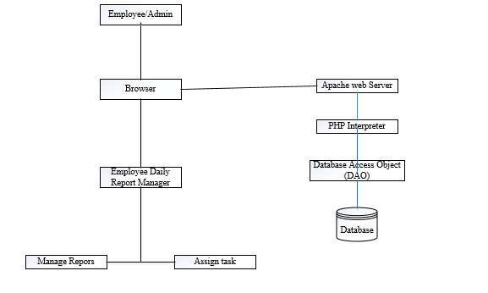

Figure 3. 1: The architecture of the system

## **3.3 Dataflow flow diagram (DFD) of the system**

The data flow diagrams model the flow of data in an information system. Figure 3.2 shows the flow of data in the system. The admin or the employee login into the system and their login information is stored. Both the admin and employees can manage the employee details. The admins (supervisors) can view, review reports of the employees (subordinates) under them. They can also assign tasks to their subordinates.

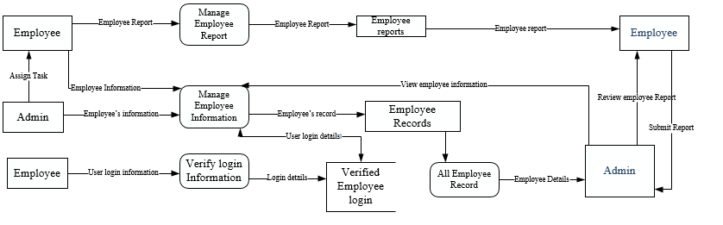

Figure 3. 2: The Data flow diagram (DFD) of employee daily report manager

## **3.4 Flow Chart**

A flowchart is a diagram that depicts a process, system or computer algorithm. They are widely used in multiple fields to document, study, plan, improve and communicate often complex processes in clear, easy-to-understand diagrams.

The flow chart in figure 3.3 below depicts the processes in the system. It shows the activities each user of the system can perform. The charts start with a start symbol which indicates the beginning of the flow. The next process is the login which serve as a gate to the system. If a user is valid, the system checks if the user is a normal employee or he has the privilege to supervise other employees. This is done to control what the user of the system can do. The flow terminates when the user logout of the system.

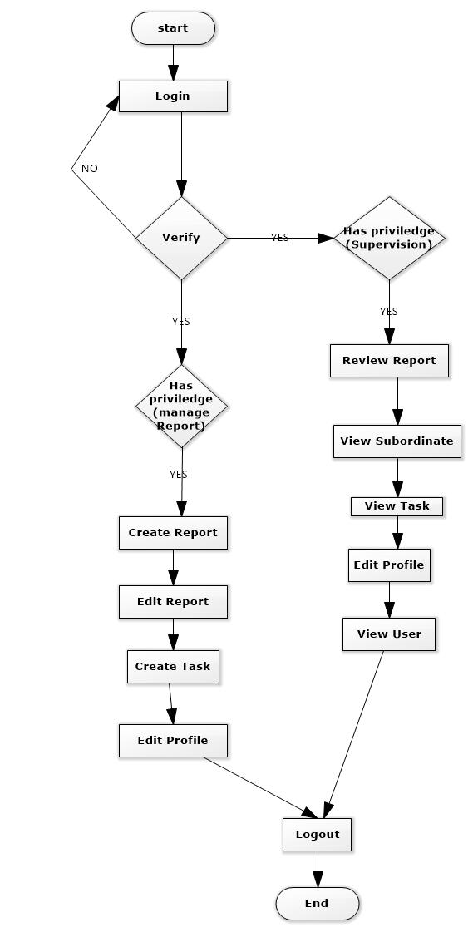

Figure 3. 3: Flow chart diagram of the system

## **3.5 Database Design**

A database is an organized collection of data for one or more purposes, usually in digital form. The data are typically organized to model relevant aspects of reality. Example, the availability ticket for booking a flight, in a way that support process requiring this information example booking a flight. The term “database” refers both to the way its user view it, and to the logical and physical materialization of its data, content in files, computer memory, and computer data storage.

Database design is the process of producing a detailed data model of a database. This logical data model contain all the needed logical and physical design choice and storage parameters needed to generate a design in a data definition language, which can be used to create a database. A fully attributes for each entity.

Database design here, shows all the data that are needed by the system and how this data is related to each other by organizing the related data into a relation and relating the respective relations to one another to form a database.

The database for this system is design using MYSQL and named as “daily_report” with thirteen tables (relations) that are logically related.

## **3.5.1 Schema**

The schema of a database is the description of the database which includes the descriptions of the database structure, data types, and the constraints on the database.

The schema for the system are as follow:

**DAILY**

|  |  |  |  |  |  |
| --- | --- | --- | --- | --- | --- |
| Id | weekly-id | Day | activity | milestone | Date_created |

**DEPARTMENT**

|  |  |
| --- | --- |
| Id | Name |

**DESIGNATION**

|  |  |  |  |  |  |  |
| --- | --- | --- | --- | --- | --- | --- |
| Id | Department_id | Name | description | Date_created | Created_by | Deletd |

**Permission**

|  |  |
| --- | --- |
| id | Permission |

**REPORT_SUMMARY**

|  |  |  |  |  |  |  |  |  |
| --- | --- | --- | --- | --- | --- | --- | --- | --- |
| Id | Weekly_id | Key_challenges | Recommendation | Rating_id | remark | Reviewer_by | Date_submitted | Date_reviewed |

**ROLE**

|  |  |  |  |  |  |
| --- | --- | --- | --- | --- | --- |
| Id | Role | description | created_by | date_created | deleted |

**ROLE_PERM**

|  |  |  |
| --- | --- | --- |
| Id | role_id | perm_id |

**SUBORDINATE**

|  |  |  |  |
| --- | --- | --- | --- |
| Id | Subordinate | Supervisor | Date_assigned |

**TASK**

|  |  |  |  |  |  |  |  |  |
| --- | --- | --- | --- | --- | --- | --- | --- | --- |
| Id | author | title | Description | Start_date | Due_date | priority | Date_created | status |

**TASK_PARTICIPANT**

|  |  |  |  |  |  |  |  |  |
| --- | --- | --- | --- | --- | --- | --- | --- | --- |
| Id | task_id | Participant_id | status | Remarks | Date_updated | Author_rating | author_remarks | Date_reviewed |

**USERS**

|  |  |  |  |  |  |  |  |  |  |  |  |  |  |
| --- | --- | --- | --- | --- | --- | --- | --- | --- | --- | --- | --- | --- | --- |
| id | first_name | last_name | email | Phone | Password | designation_id | grade_id | author_id | Last_login | Password  -changed_on | Date_created | status | deleted |

**USER_ROLE**

|  |  |  |
| --- | --- | --- |
| Id | user_id | role_id |

**WEEKLY**

|  |  |  |  |  |  |  |  |
| --- | --- | --- | --- | --- | --- | --- | --- |
| Id | User_id | Year | month | Week | Date_created | submitted | Date_submitted |

Figure 3.4: the schema diagram of the system

### *3.5.2 Entity Relationship (ER) Diagrams*

An entity relationship model is the result of using a systematic process to describe and define a subject are of business data. It does not define business process, only visualize business data, the data is represented as components (entities) that are linked with each other by relationship that express the dependencies and requirement between them.

The entity relationship diagram for this system’s database was designed using software ideas modeler. Fig 3.4 shows all the entities in the database and their attributes relationships.

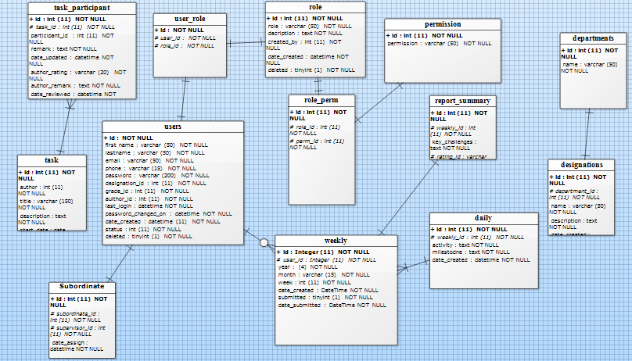

Figure 3. 5: The entity relationship diagram of the database schema

### *3.5.3 Tables*

A table is a named relational database data set that is organized by rows and columns. The relational table is a fundamental relational database concept because tables are the primary form of data storage. Columns form the table's structure, and rows form the content.

1. **Daily table**

This table stores the daily report of the employee. The table has six attributes as shown in table 3.1. The table contains an id which is auto-increment, the week-id which is a foreign key coming from the week table, the day the report was written, the report itself (Activity), milestone (achievement of the day) and the date the report was created.

Table 3. 1: Daily

|  |  |  |  |
| --- | --- | --- | --- |
| **Name** | **Datatype** | **Length** | **Constraints** |
| Id | Int | 11 | Auto_increment, NOT NULL |
| weekly_id | Int | 11 | NOT NULL |
| Day | Int | 11 | NOTNULL |
| Activity | Text |  | NOT NULL |
| Milestone | Text |  | NOT NULL |
| Date_created | Datetime |  | NOT NULL |

1. **Department table**

The department table contain list of all the department in the organization. It has an id attribute which is auto-increment and the name of the department. Table 3.2 shows attributes of the table.

Table 3. 2: Department

|  |  |  |  |
| --- | --- | --- | --- |
| **Name** | **Datatype** | **Length** | **Constraints** |
| Id | Int | 11 | Auto_increment, NOT NULL |
| Name | Varchar | 50 | NOT NULL |

1. **Designation table**

Designation table contains list of the positions of employees in the organization and their departments they belong to. Table 3.3 shows the attributes of the table

Table 3. 3: Designation

|  |  |  |  |
| --- | --- | --- | --- |
| **Name** | **Datatype** | **Length** | **Constraints** |
| Id | Int | 11 | Auto_increment, NOT NULL |
| department_id | Int | 11 | NOT NULL |
| Name | Varchar | 50 | NOTNULL |
| Description | Text |  | NOT NULL |
| date_created | Datetime |  | NOT NULL |
| dreated_by | Int | 11 | NOT NULL |
| Deleted | Tinyint | 4 | NOT NULL |

1. **Permission table**

The permission tables hold the privileges of each employee. The table has two attributes which are the id and the permission as shown in Table 3.4.

Table 3. 4: Permission

|  |  |  |  |
| --- | --- | --- | --- |
| **Name** | **Datatyp0065** | **Length** | **Constraints** |
| Id | Int | 11 | Auto_increment, NOT NULL |
| Permission | Varchar | 50 | NOT NULL |

1. **Report Summary table**

Report summary table stores the summary of each report submitted. The table contains an id, the week id, key challenges, recommendation, rating id, remark of the supervisor, supervisor id, date submitted and the date the report was reviewed. Table 3.5 shows the report summary table.

Table 3. 5: Report_summary

|  |  |  |  |
| --- | --- | --- | --- |
| **Name** | **Datatype** | **Length** | **Constraints** |
| Id | Int | 11 | Auto_increment, NOT NULL |
| weekly_id | Int | 11 | NOT NULL |
| key_challenges | Text |  | NOTNULL |
| Recommendations | Text |  | NOT NULL |
| rating_id | Int | 11 | NOT NULL |
| Remarks | Int | 11 | NOT NULL |
| reviewed_by | Int | 11 | NOT NULL |
| date_submitted | Datatime |  |  |
| date_reviewed | Datetime |  |  |

1. **Role table**

The roles table contains the roles of each of the system users. Table 3.6 shows the attributes of the table.

Table 3. 6: Role

|  |  |  |  |
| --- | --- | --- | --- |
| **Name** | **Datatype** | **Length** | **Constraints** |
| Id | Int | 11 | Auto_increment, NOT NULL |
| Role | Varchar | 50 | NOT NULL |
| Description | Text |  | NOTNULL |
| Created_by | Int | 11 | NOT NULL |
| date_created | Datetime |  | NOT NULL |
| Deleted | Tinyint | 1 | NOT NULL |

1. **Role Perm table**

The role-perm table is a table that link a permission to role. It attaches a role to a user and the grant certain permissions to the user. Table 3.7 shows the attributes of the table

Table 3. 7: Role_perm

|  |  |  |  |
| --- | --- | --- | --- |
| **Name** | **Datatype** | **Length** | **Constraints** |
| Id | Int | 11 | Auto_increment, NOT NULL |
| role_id | Int | 11 | NOT NULL |
| perm_id | Int | 11 | NOT NULL |

1. **Subordinate table**

The subordinate table show the list of all the subordinates and their supervisors. It has four attributes as shown in Table 3.8.

Table 3. 8: Subordinate

|  |  |  |  |
| --- | --- | --- | --- |
| **Name** | **Datatype** | **Length** | **Constraints** |
| Id | Int | 11 | Auto_increment, NOT NULL |
| subordinate_id | Int | 11 | NOT NULL |
| supervisor_id | Int | 11 | NOTNULL |
| date_assign | Datetime |  | NOT NULL |

1. **Task table**

This table contains all the tasks assigned to each of the employee, date assigned, due date, priority of the task, date it was created and the status as shown in Table 3.9.

Table 3. 9: Tasks

|  |  |  |  |
| --- | --- | --- | --- |
| **Name** | **Datatype** | **Length** | **Constraints** |
| Id | Int | 11 | Auto_increment, NOT NULL |
| Author | Int | 11 | NOT NULL |
| Title | Varchar | 150 | NOTNULL |
| Description | Text |  | NOT NULL |
| start_date | Date |  | NOT NULL |
| due_date | Date |  | NOT NULL |
| Priority | Varchar | 20 | NOT NULL |
| date_created | Datetime |  | NOT NULL |
| Status | Tinyint | 1 | NOT NULL |

1. **Task participant table**

The task participant table contains the name of the employee/employees task is assign to, the task id, the task status, the remark, the date the task was updated and the author rating. The attributes of the table are described in Table 3.10

Table 3. 10: Task_participants

|  |  |  |  |
| --- | --- | --- | --- |
| **Name** | **Datatype** | **Length** | **Constraints** |
| Id | Int | 11 | Auto_increment, NOT NULL |
| task_id | Int | 11 | NOT NULL |
| participant_id | Int | 11 | NOTNULL |
| Status | Tinyint | 1 | NOT NULL |
| Remarks | Text |  | NOT NULL |
| date_updated | Dateime |  | NOT NULL |
| author_rating | Text |  | NOT NULL |
| author_remarks | Text |  | NOT NULL |
| date_reviewed | Datetime |  | NOT NULL |

1. **Users table**

The users table shows all the list of the users of the system. It contains the user bio data, their designation, their grades (permissions), the author, date the user was created, status of the user and login information. Table 3.11 shows all the attributes of the table.

Table 3. 11: Users

|  |  |  |  |
| --- | --- | --- | --- |
| **Name** | **Datatype** | **Length** | **Constraints** |
| Id | Int | 11 | Auto_increment, NOT NULL |
| first_name | Varchar | 50 | NOT NULL |
| last_name | Varchar | 50 | NOTNULL |
| Email | Varchar | 50 | NOT NULL |
| Phone | Varchar | 15 | NOT NULL |
| Password | Varchar | 200 | NOT NULL |
| designation_id | Int | 11 | NOT NULL |
| grade_id | Int | 11 | NOT NULL |
| author_id | Int | 11 | NOT NULL |
| last_login | Datetime |  | NOT NULL |
| Password_changed_on | Datetime |  | NOT NULL |
| date_created | Datetime |  | NOT NULL |
| Status | Int | 11 | NOT NULL |
| Deleted | Tinyint |  | NOT NULL |

1. **User role table**

This table maps a user to a role. It has three attributes as shown in Table 3.12.

Table 3. 12: User_role

|  |  |  |  |
| --- | --- | --- | --- |
| **Name** | **Datatype** | **Length** | **Constraints** |
| Id | Int | 11 | Auto_increment, NOT NULL |
| user_id | Int | 11 | NOT NULL |
| role_id | Int | 11 | NOTNULL |

1. **Weekly table**

Weekly table shows the details of the week a report was submitted. It contains an id, user id, year, month, week, date the report was created, status of the report (either submitted or not) and the date it was submitted. Table 3.13 shows the attributes of the weekly table.

Table 3. 13: Weekly

|  |  |  |  |
| --- | --- | --- | --- |
| **Name** | **Datatype** | **Length** | **Constraints** |
| Id | Int | 11 | Auto_increment, NOT NULL |
| User_id | Int | 11 | NOT NULL |
| Year | Year | 4 | NOTNULL |
| Month | varchar | 15 | NOT NULL |
| Week | Int | 11 | NOT NULL |
| date_created | Datetime |  | NOT NULL |
| Submitted | Tinyint | 1 | NOT NULL |
| date_submitted | Datetime |  | NOT NULL |

## **3.6 Tools**

A programming tool or software development tool is a computer program that software developers use to create, debug, maintain, or otherwise support other programs and applications. The term usually refers to relatively simple programs, that can be combined together to accomplish a task, much as one might use multiple hand tools to fix a physical object. The programming tools used to achieve the implementation of the proposed system of this project work are as follows:

### *3.6.1 HTML5 (HyperText Markup Language version 5)*

HTML is a markup language for creating Web pages and other information that can be displayed on a Web browser. Since it was introduced, HTML has evolved through series of versions, but version 5 is the latest version was used for the development of this project due to it wide range of new features which were added to provide better programming experience.

### *3.6.2 CSS3 (Cascading Style Sheet version 3)*

CSS is a style sheet language used for describing the presentation semantics of a document written in a mark-up language. It most common application is to enable the separation of document content from document presentation, including elements such as the layout, color, and fonts. This separation can improve content accessibility, provide more flexibility and control. CSS can also allow the same mark-up pages to be presented in different rendering methods. It is designed with a priority scheme to determine which rules apply if more than one rules match against a particular element (Christopher, 2004).

### *3.6.3. JavaScript and Jquery*

JavaScript is an implementation of the ECMAScript language standard and is typically used to enables programmatic access to computational object within a host environment.it can be characterized as a prototype-based object-oriented scripting language that is dynamic, weakly typed and has first class functions (Sebesta, 2010). In this project JavaScript was used to request all the required form inputs making sure each input is properly filled as required and loading all the required resources

Jquery on the other hand is a JavaScript library. It is a fast and feature-rich library that makes things like HTML document traversal and manipulation, event handling, animation and ajax much easier with an easy-to-use API that works across a multitude of browsers. I used Jquery in this project to reduce the stress of writing some JavaScript codes.

### *3.6.4 PHP7 (Hypertext pre-processor version 7)*

Hypertext Pre-processor (PHP) is a server-side scripting language designed for Web development. It is simple, fast and portable well suited for development of database enabled for web site *(Ellie Quigley, Marko Gargenta, 2006)*. It runs on the server and generally cannot run on its own unless in response to an event. It is designed for use with HTML such that when invoked, it returns HTML to the browser. It provides more flexibility than HTML alone. PHP has extended capabilities of a full-featured programming language, capable of managing huge database driven online environment *(Zandstra, 2003).* It is also platform independent, powerful, robust and scalable specifically designed for web development. It can be object oriented, it has great documentation in different languages, and it has large active developer community.

I chose PHP over some other scripting languages is that apart from the fact that PHP is an open source programming language, it easy to learn, it is user friendly and secured. It is object oriented which has the ability to call java and window COMS objects. It also makes it easy to access other web-based tools like google map or any other.

### *3.6.4 XAMPP*

XAMPP stands for Cross-Platform (X), Apache (A), MariaDB (M), PHP (P) and Perl (P). It is a free and open source cross-platform web server solution stack package developed by Apache Friends (Wikipidea,2018). It consists mainly of the Apache HTTP Server, MariaDB database, and interpreters for scripts written in the PHP and Perl programming languages. It is a simple, lightweight Apache distribution that makes it extremely easy for developers to create a local web server for testing and deployment purposes.

I used XAMPP in this project because it is cross-platform, which means it works equally well on Linux, Mac and Windows unlike the WAMP and MAMP and LAMP which were for windows, Macs and Linux respectively.

### *3.6.5 MySQL*

MySQL is a relational database management system (RDBMS) used to manipulate or manage data contained in a database. (Christopher, 2004). MySQL is fast and easy-to-use being used for many small and big businesses. MySQL is developed, marketed, and supported by MySQL AB, which is a Swedish company (MySQL Tutorial, 2014). It is used to store information. It uses ‘’Structured Query Language’’ which is the most common database language used for adding, removing and modifying information in the database. MYSQL content can be managed via command line or a web interface.

### *3.6.6 Sublime Text version 3*

A text editor is a program developers write their code in. Sublime Text is a text editor written in C++ and Python available on windows, Mac and Linux.

I chose sublime text version 3 which is the latest version to write my code because it is user friendly and it is cross-platform.

# **CHAPTER FOUR**

# **IMPLEMNTATION OF EMPLOYEE DAILY REPORT MANAGER**

## **4.1 Introduction**

Software implementation entails all the post-sale processed involved in something operating properly in its environment, including analyzing requirements, installation, configuration, customization, running, testing, system training, delivering and making necessary changes. In this chapter I will discuss about the system requirement, application user interface, application testing and the discussion of my achievements.

## **4.2 System Requirement**

System requirements are the configuration that a system must have in order for a hardware or software application to run smoothly and efficiently. Employee daily report manger is a web application which runs on a server. Users interact with the application via a web browser on any computer or mobile device that have access to the internet or the network where the server is hosted (example, a localhost).

In this project, the following are the system requirements for proper functioning of the system.

1. **Server-side requirement:** The application was built using PHP which is server-side scripting language. This means that it must be run on a web server that supports PHP.
2. **Operating Systems:** Windows* Server, Linux*, or any operating system that can run as a webserver, capable of delivering HTML5 content, including JSON and MP4.
3. **Web server:** XAMPP 7.2.1 which contain an Apache 2.2.x or 2.4.x, PHP 7 and MariaDB (MYSQL 5) is recommended for this application
4. **Processor:** Computer with intel, Celeron Processor 847, 1.10 GHz, or faster processor.
5. **Memory:** The storage space should be between 1.3 GB - 2.3GB.
6. **Hard disk:** 5GB of available hard disk space.
7. **RAM:** Minimum of 512 MB RAM is required.
8. **Database:** MYSQL 5.1 and above.

## **4.3 Application User Interface**

This section highlights the major user interfaces of the system in order to provide some explanation of how the system works.

The system works in a very easy and friendly way starting from the login to writing the report and assigning tasks. It has four categories of users each with their roles as follows:

1. Admin I: manages everything in the application
2. Admin II: manages reports and has supervision privilege
3. Admin III: manages reports only
4. Admin IV: manages all.

The system has a login user interface where the user can be authenticated before he/she get access to the system. The user does that after he/she has been registered to the system by the admin. It also has interface for the admins to update, view his/her profile and reset password. Adding new user to the system is done by either Admin I or Admin IV. They can create a profile for any new user be registered into the system. The admins can also edit and view any user profile. Admin IV is the only one that has the privilege to delete any user from the system.

### *4.3.1 The Login Page*

This is the first page that will be displayed to any user that accesses the system. The interface authenticates the user before getting access to other interfaces of the system. Any user with an invalid login details or try to access any other interface before been authorized will be redirected back to this page. The login page is shown in Figure 4.1.

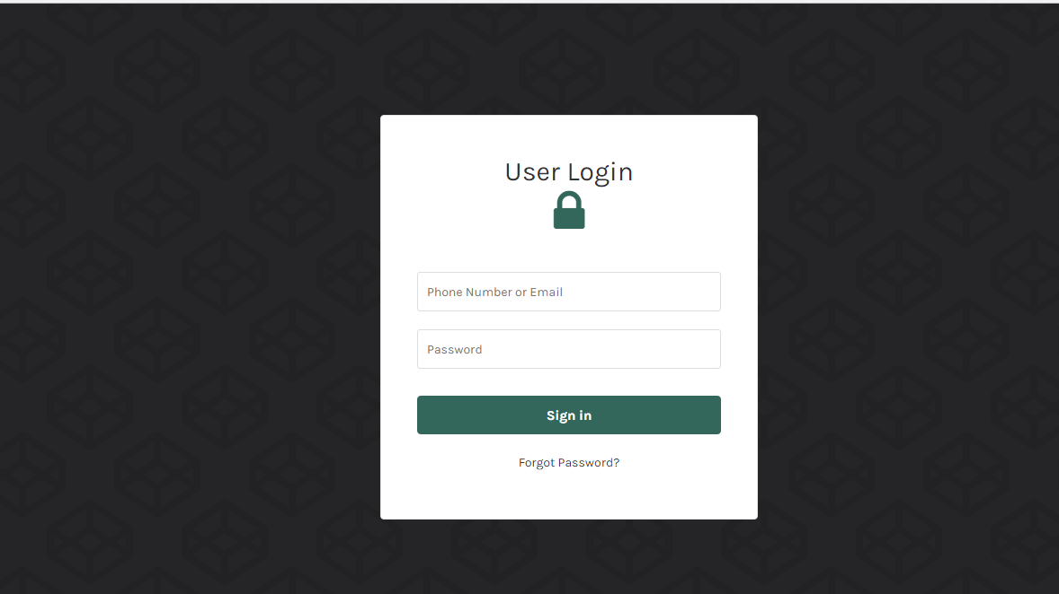

Figure 4. 1: The login page for the system

`

### *4.3.2 The Report Page*

This is the first interface after a user have successfully logged into the system. The page contains the daily report of the employee. It has table which contains the details of all the reports the employee has been writing. It contains the months/year in which the report was written, the week, status (whether submitted or not), rating, and date created. The user can view and edit the report. The page also has a button to add new report. The user can only write one report per day but can edit the report before submission. The report page is shown in Figure 4.2.

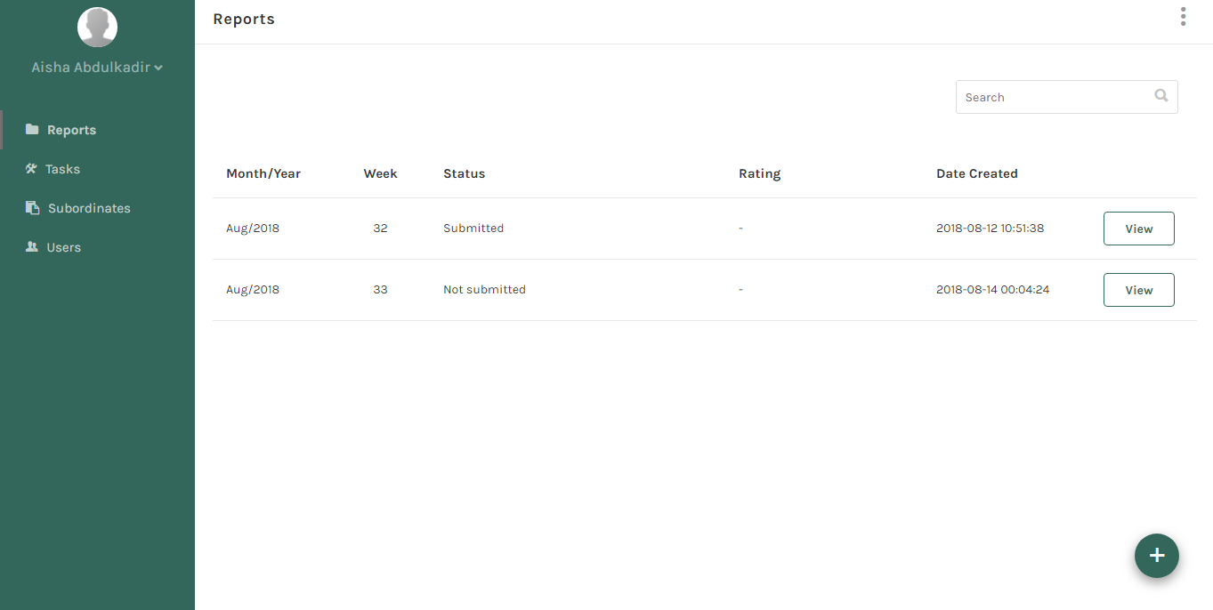

Figure 4. 2: The report page

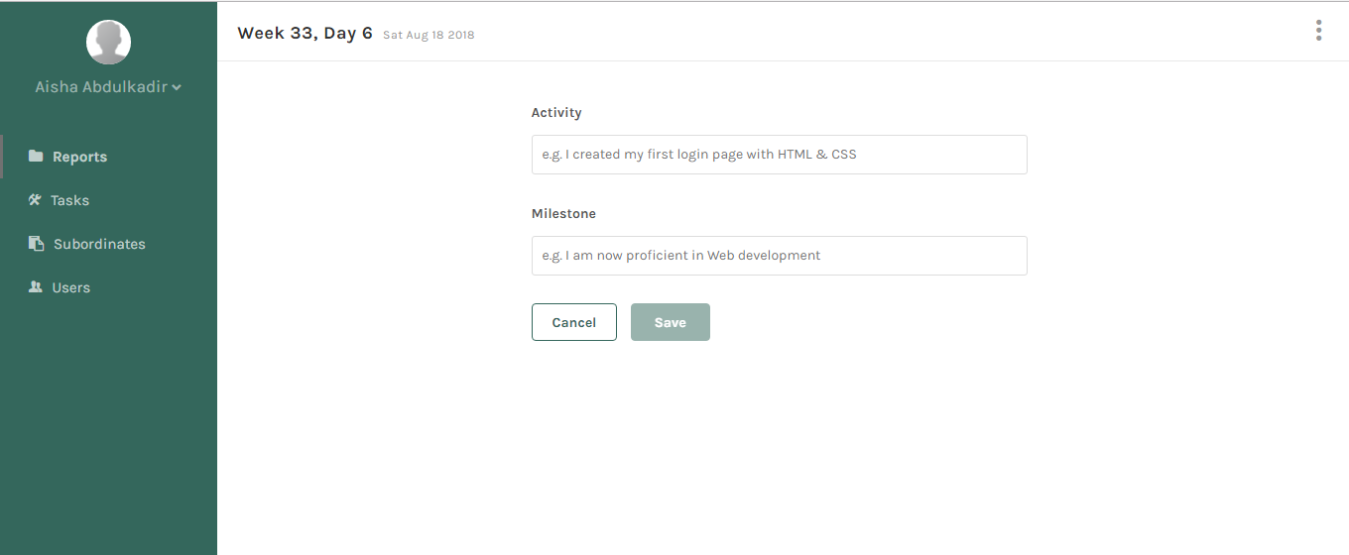

Figure 4. 3: The add report page where a user can create new report.

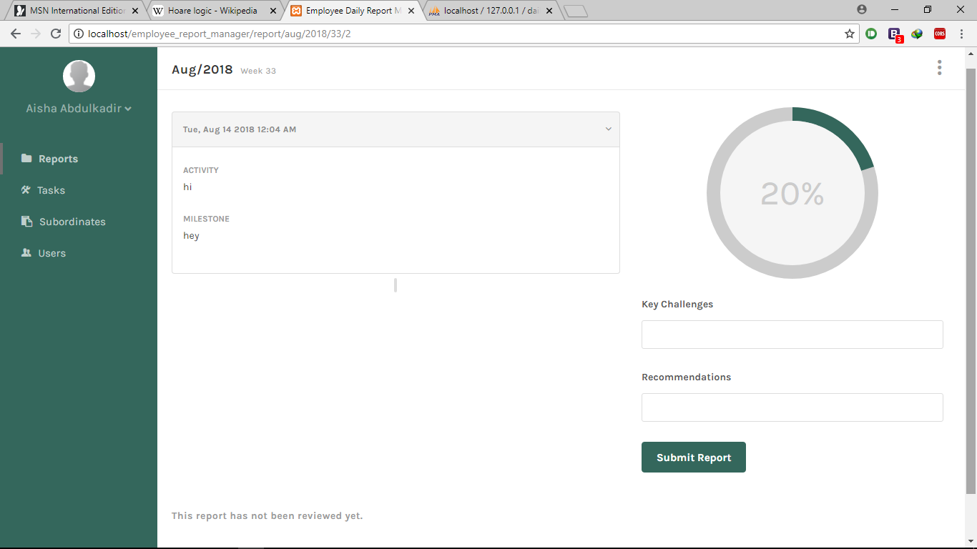

Figure 4. 4: Submit a report

### *4.3.3 Task page*

The task interface is where an employee can view task assigned to him/her. The application allow task to be assigned to both the supervisors and the subordinates. Once a task assigned, the application shows the task description, start date, due date, priority and participant/ participants of the task as shown in Figure 4.4. After the task is completed the status is set on which informs the person that assigned the task. He can then write a remark on the task as shown in Figure 4.5. The in Figure 4.6 shows the details of the report

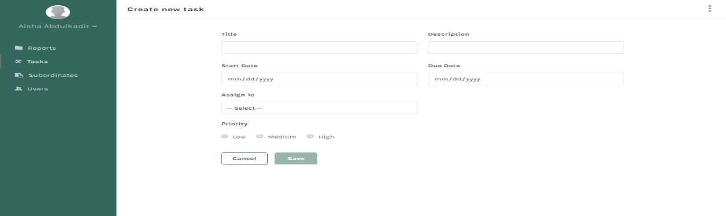

Figure 4. 5: Create new task page

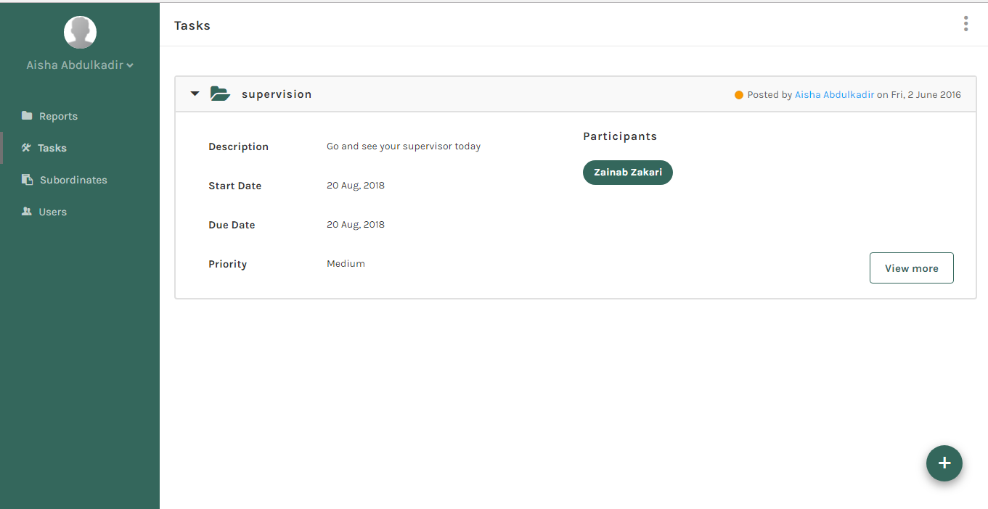

Figure 4. 6: The view tasks page

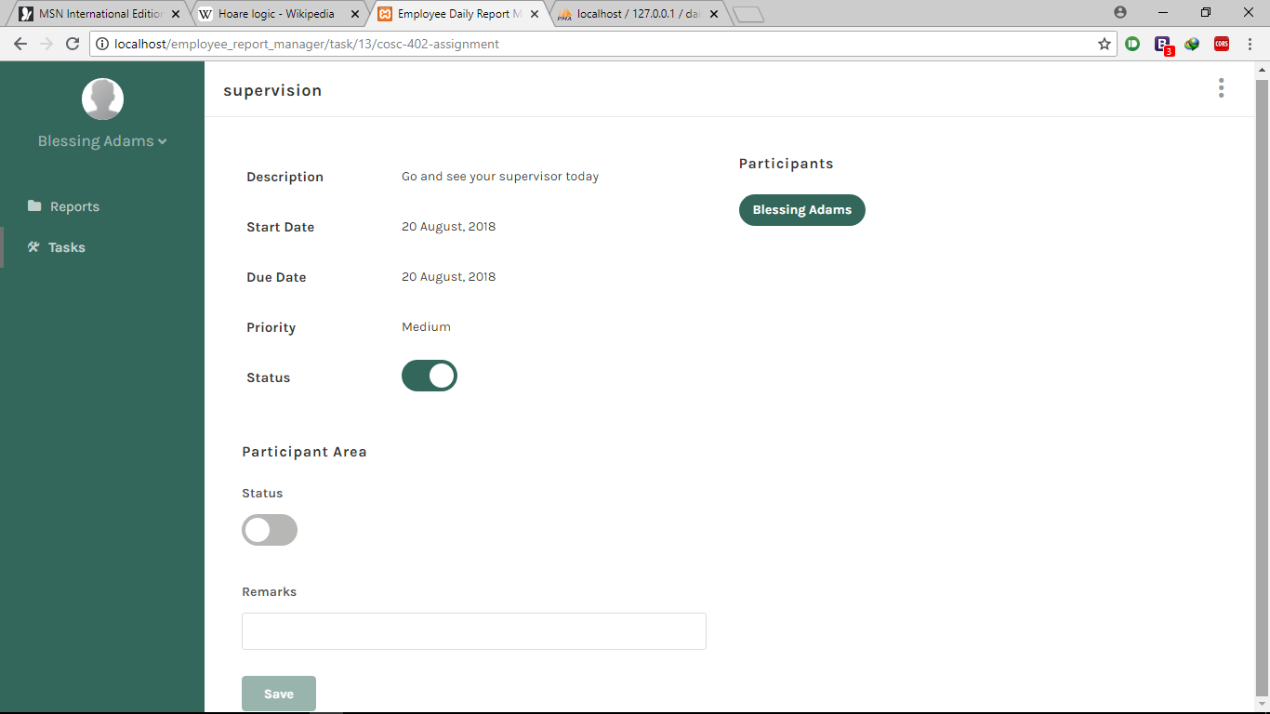

Figure 4. 7: The remark page.

### *4.3.4 Subordinate page*

The page contains a table that show all the subordinates assigned to a particular supervisor. The table contains the subordinate’s name, email, designation and the date it was created. The supervisor can view each subordinate information by clicking on the view button.

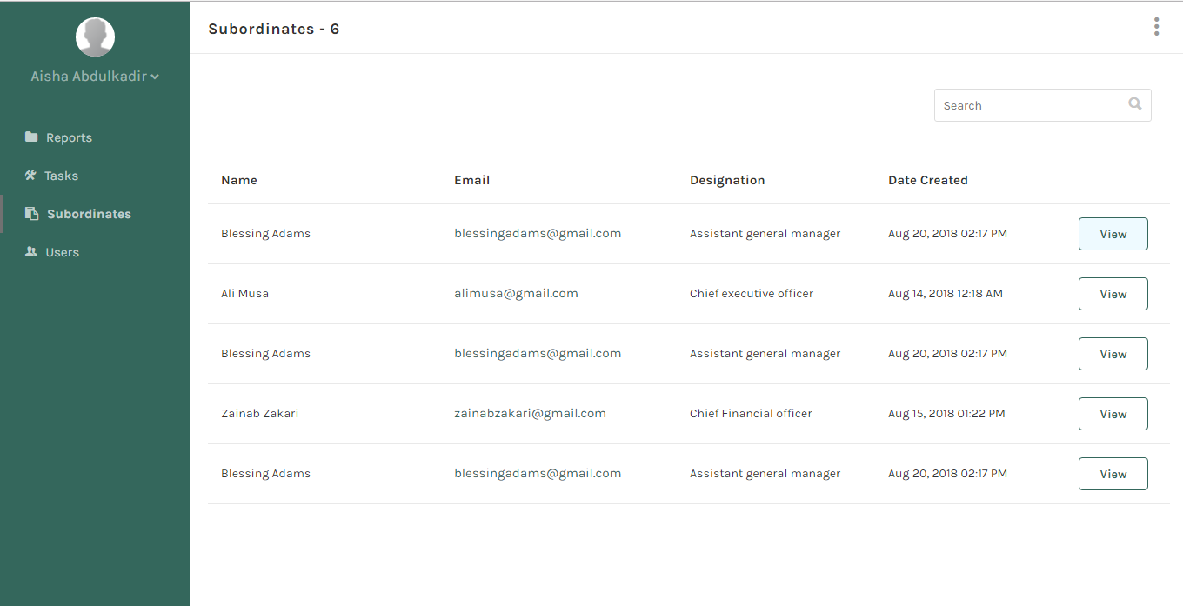

Figure 4. 8: The subordinate page

### *4.3.5 Users page*

This page is only displayed to certain users of the system only depending on the role of the user. The page contains list of all the users of the system. It contains their staff IDs, names, emails and their designations. You can view, edit and delete (this can only be done by the system administrator) a user. The page also contains a button to a new user.

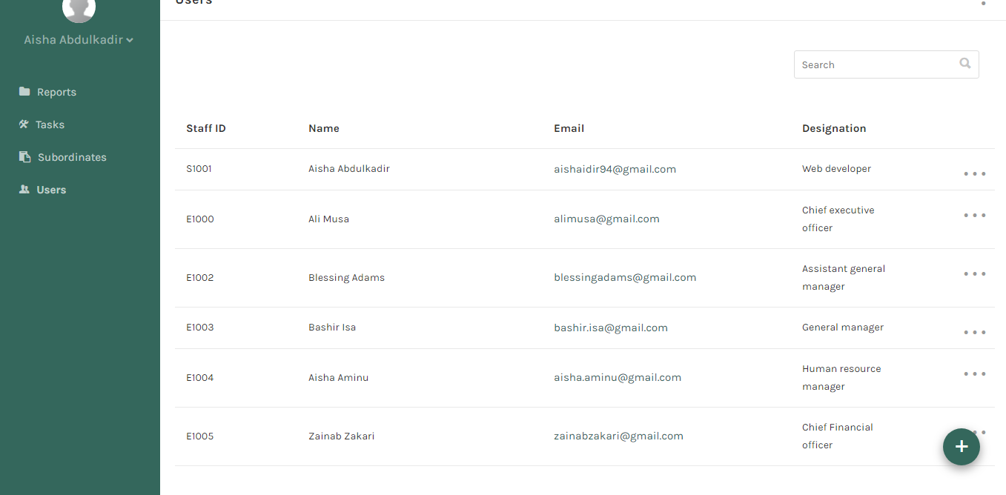

Figure 4. 9: The users’ tables

## **4.4 Application testing**

Testing is intended to show that a program does what it is intended to do and to discover program defects before it is put into use. So in this section I carried out three main tests to ensure the proper functionality of the system.

### *4.4.1 Interface testing*

Interface Testing is performed to evaluate whether systems or components pass data and control correctly to one another. It is to verify if all the interactions between these modules are working properly and errors are handled properly

In this application, I tested three major areas. They are as follow:

1. **Application Testing**: Requests are sent correctly to the Database and output at the client side is displayed correctly. Also, errors are caught and handles appropriately.
2. **Web Server:** The local web server (Apache) handles all the application request without any service denial.
3. **Database Server:** All the queries sent to the database are correct and the results were displayed correctly.

### *4.4.2 Usability Testing*

Usability testing is a non-functional testing technique that is a measure of how easily the system can be used by end users. This application was evaluated under the following parameters:

1. **Level of skill required to learn/use the software**: Employee daily report manager does not require special skill for a start. It simply requires an internet connection.
2. **Time require to get used to using the system**: the application does not require much time to get used to. All it takes is a little guide on how the application works.
3. **Measure of increase in Employee’s production**: The application serves as an employee monitoring device that an employer can used to keep track of all the employees’ activities. It increases the level of employees’ engagement at work which increase production.
4. **Assessment of employees towards using the software**: The employees were resistant at first as they felt being monitored by their employer or superiors in the office. This was tackled with time as they became used to the system.

### *4.4.1 Acceptance Testing*

Acceptance testing, a testing technique performed to determine whether or not the software system has met the requirement specifications. The main purpose of this test is to evaluate the system's compliance with the business requirements and verify if it is has met the required criteria for delivery to end users.

Various forms of acceptance testing include the user acceptance testing, business acceptance testing, alpha testing and beta testing. I only did the user acceptance testing.

User acceptance testing, is a testing methodology where the client/end users involved in testing the product to validate the product against their requirements. It is performed at client location at developer's site. In this project the client/end users used are my fellow students. The application was tested and it functioned as specified.

## **4.5 Discussion**

The primary objectives of developing this application was realized. I was able to design the login system that authenticate users before they are allowed into the system. Hypertext Markup Language (HTML) was used to mark up the form tags and Cascading Style Sheet (CSS) was used to style it. JavaScript was used to handle user’s input errors and hypertext pre-processor (PHP) was used to validate the user’s information from the database.

Next I was able to design a page that enable the system users to assign tasks. This page was designed using the HTML, CSS, JavaScript and PHP. The page was first marked up with HTML then it was styled with the CSS, JavaScript was used to handle errors and PHP was used to fetch user information and save task assigned to the database.

Also, I designed an interface that allows employee to report their daily activity. The page contains a table which carry the summary of the report and the status whether it has been submitted or not. The user can click on the view button to view reports, edit report before submission. The page also contains form inputs that allow the employees to state their key challenges and their recommendations.

Most importantly, I was able to design a well-structured database that will provide an immediate storage and retrieval of data and information. The database was designed with phpMyAdmin version 10 and was named daily report. The database has 18 tables and 3 views.

## **CHAPTER FIVE**

## **SUMMARY, CONCLUSION AND RECOMMENDATION**

## **5.1 Introduction**

This chapter presents the summary of what has been discussed so far in the documentation of the project application. It contains the conclusion and the recommendation.

## **5.2 Summary**

This project focused on the design and implementation of web based employee daily report manger. The application was developed to help employees keep track of their daily activities in their work place. This system also helps the employers monitor the activities of their employees. The application was built using the Hypertext Markup Language (HTML), Cascading Style Sheet (CSS) and JavaScript as the client side Scripting language. Hypertext Pre-processor (PHP) was used as the server side language.

The system contains major components like the report page where user write reports, the task page where user can assign tasks or view task assigned to him.

## **5.3 Conclusion**

In conclusion, web based employee daily report manager is very easy project that can be develop and implemented, and actualize when given adequate time without haste. The objectives of this project were achieved and the system that has been designed will enable the management perform more efficiently.

## **5.4 Recommendations**

Based on this project, I recommend the following:

1. The project should be implemented by the organization that is designed for as it is very important for both the employees and the employers to keep track of their activities.
2. I recommend the improvement of the application as there are several features that can be added to the system such as the time tracking to track the number of hours each employee spend at work and scheduling features to help employee organize his or her work.
3. I also recommend that the user of the system should use the basic system requirement listed in chapter four of this project documentation.

# **REFERENCE**

Business Dictionary, (2018), Employee. [online] Available:

http://www.businessdictionary.com/definition/employee.html.

(April 26, 2018).

Cameron, M., & Goldman, Y., (2013). Design of an Automated Employee

Scheduling System. San Luis Obispo: Faculty of California Polytechnic

State University.

Elmasiri, R., and Navathe, S. (2007). Fundamental of database System (6th Ed),

Boston: Rights and contacts Department., pp. 199.

Elmasiri, R., and Navathe, S. (2007). Fundamental of database System (6th Ed),

Boston: Rights and contacts Department., pp. 309

Employee New Zealand, (2018), Employment New Zealand. [online] Available:

https://www.employment.govt.nz/starting-employment/who-is-an-employee.

(June 21,2018).

Smith, M. P. (2010, June). Automated Employee Scheduling System. [online]

Available

calpoly.edu: http://digitalcommons.calpoly.edu/cscsp/8/. (April 30, 2018).

Ilo, P. I., & Ifijeh, G. I., (2010). Impact of the Internet on Final Year Students,

Research: Case Study of Convenat University, Ota, Nigeria. Library

Philosophy andpractice (e-journal), pp 7-27.

Ndegwa, A., (2016). What is a Web Apllication. [online] Available:

www.maxcdn.com/one/visual-glossary/web-application/. (May 31, 2016)

Skyler, Heather, (2018), How to Write a Daily Report. [online] Available:

https://bizfluent.com/how-5093085-write-daily-report.html. (April 26,2018).

Srikantaiah, T. K., & Xiaojy, D. (1998). The Internet and Its Impact on Developing countries: examples from China and India. Asian Libraries, pp 199 - 209.

Status, (2017), Employees Daily Reporting of Accomplishments – Best Practices.

[online] Available:

https://status.net/articles/employees-daily-reporting/. (April 26, 2018).

Wikipedia, (2018), web application. [online] Available:

https://en.wikipedia.org/wiki/Web_application. (April 26, 2018).

# **APPENDIX**

**// Index.php**

<?php

require_once 'models/init.php';

?>

<!DOCTYPE html>

<html>

<head>

<meta charset="UTF-8">

<title>Login | Employee Daily Report Manager</title>

<meta name="description" content="">

<meta http-equiv="Cache-Control" content="no-cache, no-store, must-revalidate"/>

<meta http-equiv="Pragma" content="no-cache"/>

<meta http-equiv="Expires" content="0"/>

<?php include_once("incs/src_links.php"); ?>

</head>

<body class="bg_gray">

<!-- page_container -->

<div class="page_container">

<div class="prompt_msg"></div>

<!-- display_table -->

<div class="display_table">

<!-- display_table_cell -->

<div class="display_table_cell">

<!-- access_screen -->

<div class="access_screen">

<!-- access_screen_logo -->

<span style="fontsize:30px;padding:10px;">User Login</span>

<div class="access_screen_logo">

<i class="fa fa-lock" style="font-size:54px;color:#34675c;"></i>

<a href="./">

<img src="imgs/logo.png">

<span>Employee report manger Manager</span>

</a>

</div>

<!-- /access_screen_logo -->

<!-- access_screen_form -->

<form action="javascript;" class="access_screen_form" id="login_form" data-controller="user" form-type="login">

<input type="hidden" id="action" name="action" value= "login">

<!-- form_group -->

<div class="form_group">

<input type="text" class="form_val required" name="phone_email" placeholder="Phone Number or Email">

</div>

<!-- /form_group -->

<!-- form_group -->

<div class="form_group">

<input type="password" class="form_val required" name="password" placeholder="Password">

</div>

<!-- /form_group -->

<!-- form_action -->

<div class="form_action">

<button type="button" class="button full_button primary_button process" data-form="login_form" id="login_form_button" onclick="javascript:processForm('login_form', 'Sign in')" >Sign in </button>

</div>

<!-- /form_action -->

</form>

<!-- /access_screen_form -->

<!-- access_screen_footer -->

<div class="access_screen_footer align_center">

<a class="" href="password-reset.php">Forgot Password?</a>

</div>

<!-- /access_screen_footer -->

</div>

<!-- /access_screen -->

</div>

<!-- /display_table_cell -->

</div>

<!-- /display_table -->

</div>

<!-- /page_container -->

</body>

</html>

**//Report page**

<?php

include_once("models/init.php");

include_once("incs/auth.php");

if(!$user->hasPrivilege("Manage Reports")) {

echo "No permission";

die;

}

$today = date("Y-m-d");

$report = new Report;

$date = new DateTime($today);

$week = $date->format("W");

//$week = $report->getWeek($today, "sunday");

$dayofweek = date('W', strtotime($today)) == 0 ? 7 : date('w', strtotime($today));

$year = date('Y', strtotime($today));

$month = date('M', strtotime($today));?>

<!DOCTYPE html>

<html>

<head>

<meta charset="UTF-8">

<title><?php echo $siteTitle; ?></title>

<meta name="description" content="">

<meta http-equiv="Cache-Control" content="no-cache, no-store, must-revalidate"/>

<meta http-equiv="Pragma" content="no-cache"/>

<meta http-equiv="Expires" content="0"/>

<?php include_once("incs/src_links.php"); ?>

<script type="text/javascript">

$(function() {

disableFormButton('report_form', 'report_form_button');

});

</script>

</head>

<body>

<!-- light_overlay -->

<div class="light_overlay"></div>

<!-- /light_overlay -->

<!-- page_container -->

<div class="page_container">

<!-- aside -->

<?php include_once("incs/aside.php"); ?>

<!-- /aside -->

<!-- header -->

<header cleafix>

<div class="mobile_navicon pull_left">

<i class="ion ion-navicon"></i>

</div>

<h3 class="page_title clearfix">

<span>Week <?php echo $week .", Day " . $dayofweek;?>

</span><spanclass="page_title_date"><?php echo date("D M d Y") ?></span>

</h3>

<!-- header_widgets -->

<?php include_once("incs/header_widgets.php"); ?>

<!-- header_widgets -->

</header>

<!-- /header -->

<!-- page_content -->

<div class="page_content">

<div class="prompt_msg"></div>

<!-- form_section -->

<div class="form_section">

<form action="javascript:void(0)" class="form_center_auto" id="report_form" data-controller="report" form-type="create_daily_report">

<input type="hidden" name="year" value="<?php echo $year; ?>">

<input type="hidden" name="month" value="<?php echo $month; ?>">

<input type="hidden" name="week" value="<?php echo $week; ?>">

<input type="hidden" name="day" value="<?php echo $dayofweek; ?>

<!-- row -->

<div class="row">

<!-- column_12 -->

<div class="column_12">

<!-- row -->

<div class="row">

<!-- column_12 -->

<div class="column_12">

<!-- form_group -->

<div class="form_group">

<!-- row -->

<div class="row no_margin">

<!-- column_12 -->

<div class="column_12">

<label>Activity</label>

</div>

<!-- /column_12 -->

<!-- column_12 -->

<div class="column_12 form_item">

<textarea class="form_val required" placeholder="e.g. I created my first login page with HTML & CSS" name="activity" id="activity"></textarea>

<span class="validation_error" id="activity_error"></span>

</div>

<!-- /column_12 -->

</div>

<!-- /row -->

</div>

<!-- /form_group -->

<!-- form_group -->

<div class="form_group">

<!-- row -->

<div class="row no_margin">

<!-- column_12 -->

<div class="column_12">

<label>Milestone</label>

</div>

<!-- /column_12 -->

<!-- column_12 -->

<div class="column_12 form_item">

<textarea class="form_val" placeholder="e.g. I am now proficient in Web development" name="milestone" id="milestone"></textarea>

<span class="validation_error" id="milestone_error"></span>

</div>

<!-- /column_12 -->

</div>

<!-- /row -->

</div>

<!-- /form_group -->

</div>

<!-- /column_12 -->

</div>

<!-- /row -->

</div>

<!-- /column_12 -->

<!-- column_12 -->

<div class="column_12">

<!-- form_action -->

<div class="form_action">

<button class="button default_button small" onclick="window.location='<?php echo $baseURL; ?>reports'">Cancel</button>

<button type="button" class="button primary_button small process" data-form="report_form" id="report_form_button" disabled="disabled" onclick="javascript:processForm('report_form', 'Save')">Save</button>

</div>

<!-- /form_action -->

</div>

<!-- /column_12 -->

</div>

<!-- /row -->

</form>

</div>

<!-- /form_section -->

</div>

</div>

<!-- /page_container -->

</body>

</html>